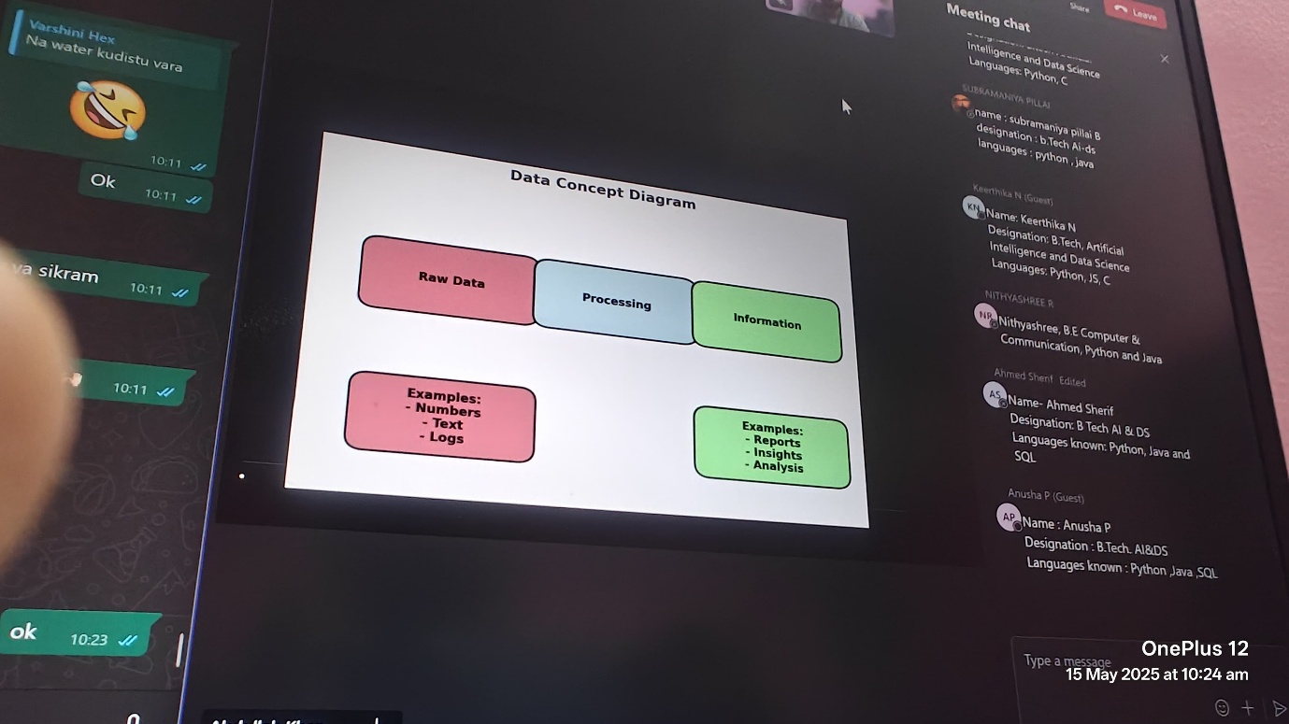

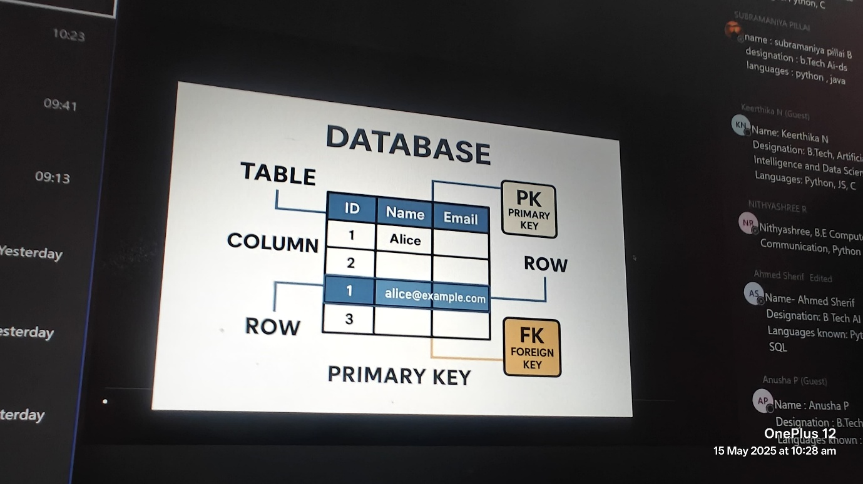

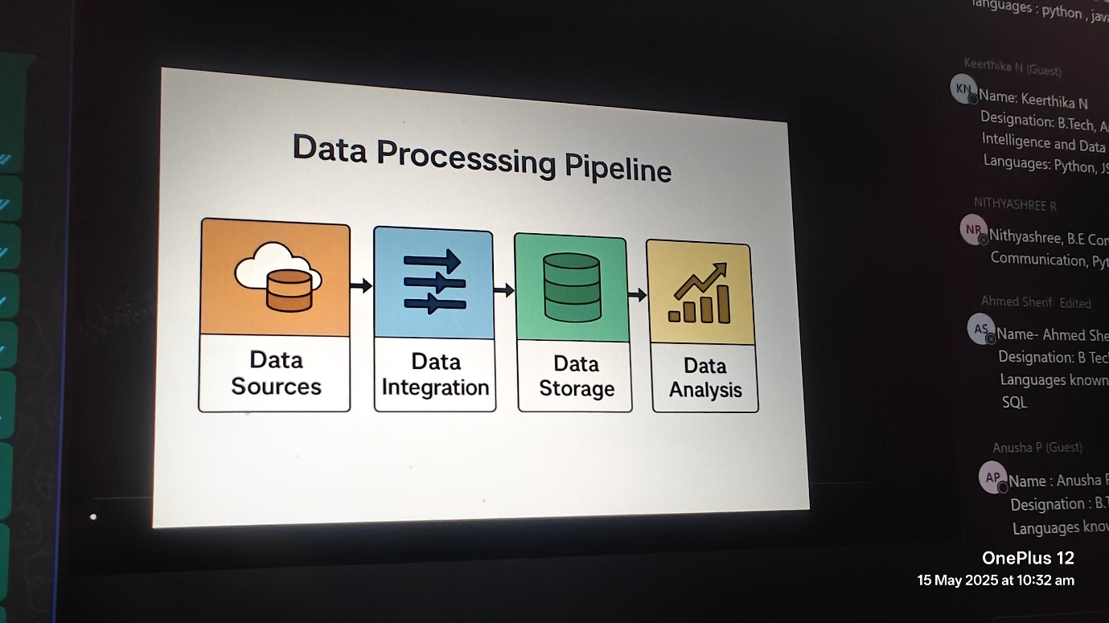

data source: source from where data come from

data integration: integrating the data

data storage: storing the data

data analysis: analysisng the data

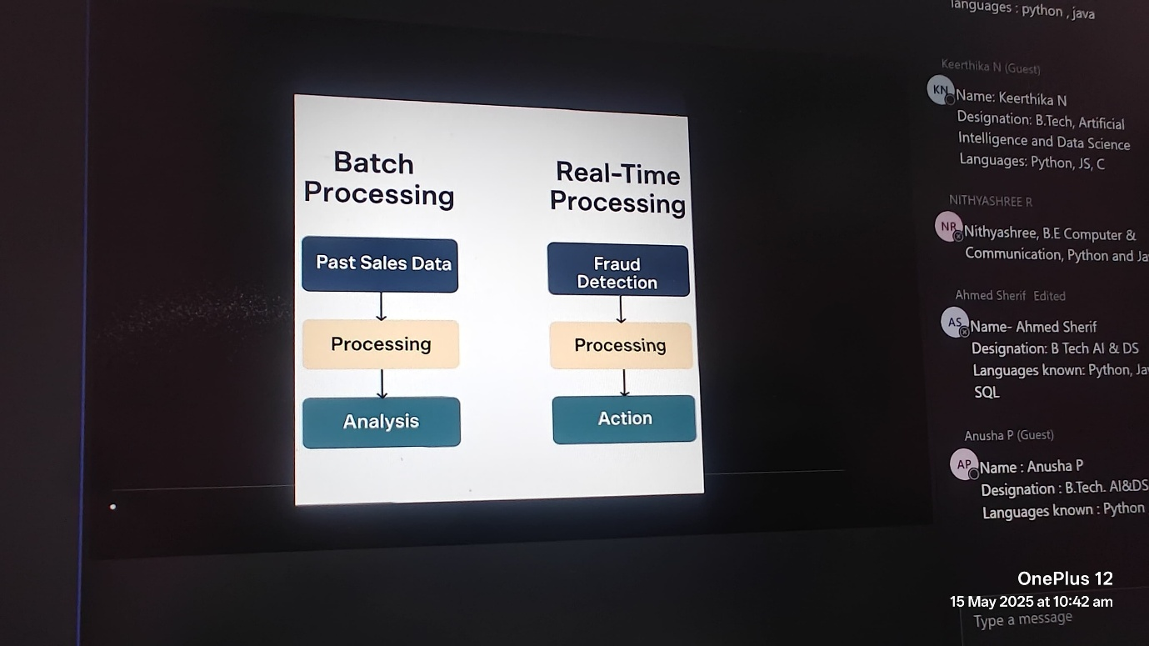

batch processing (already have the data and is processed): past sales data -> processing -> analysis

real-time processing (data is processed in realtime): fraud detection -> processing -> action

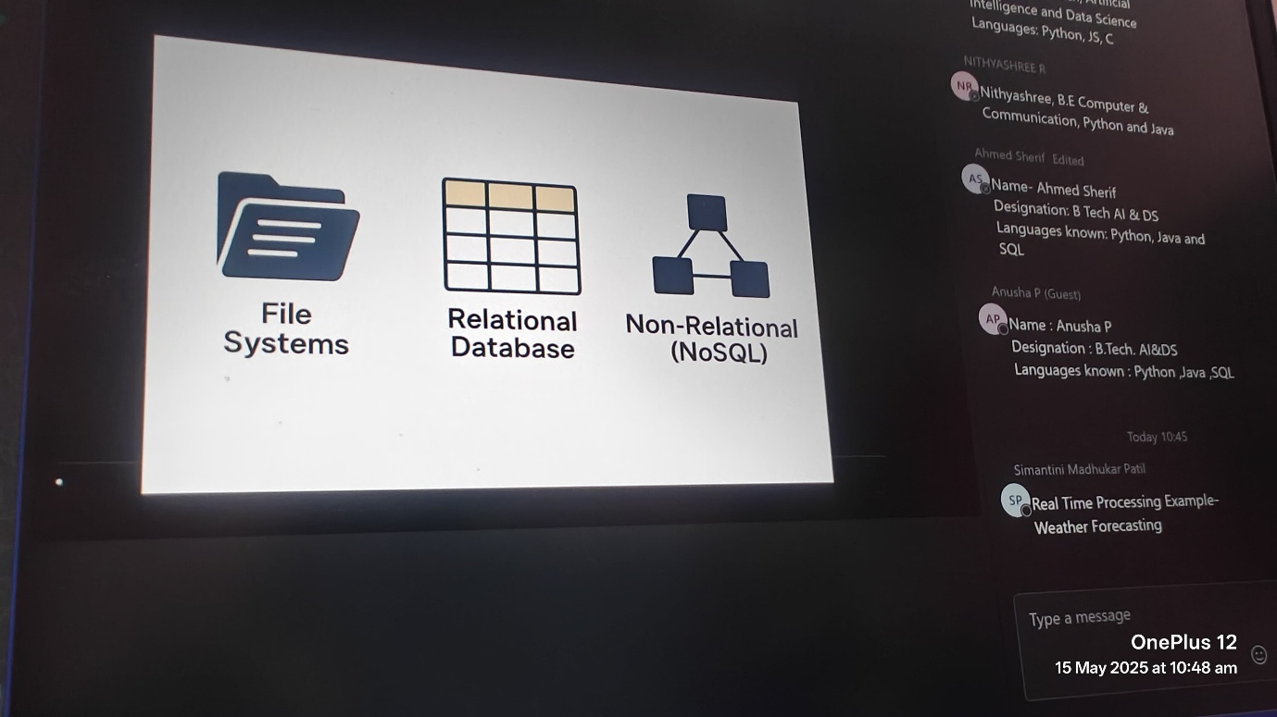

file system - files

relational database - has relation

non-relational (No sql) - no structure

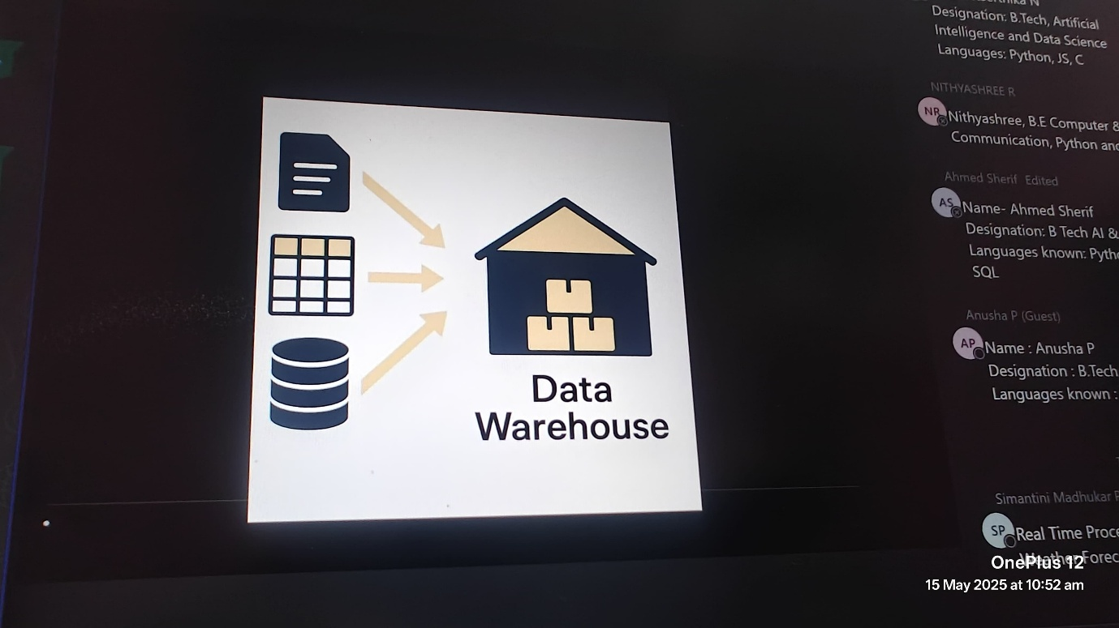

data warehouse - store all the data (all types (file system,relational db, non-relational)/ everything)

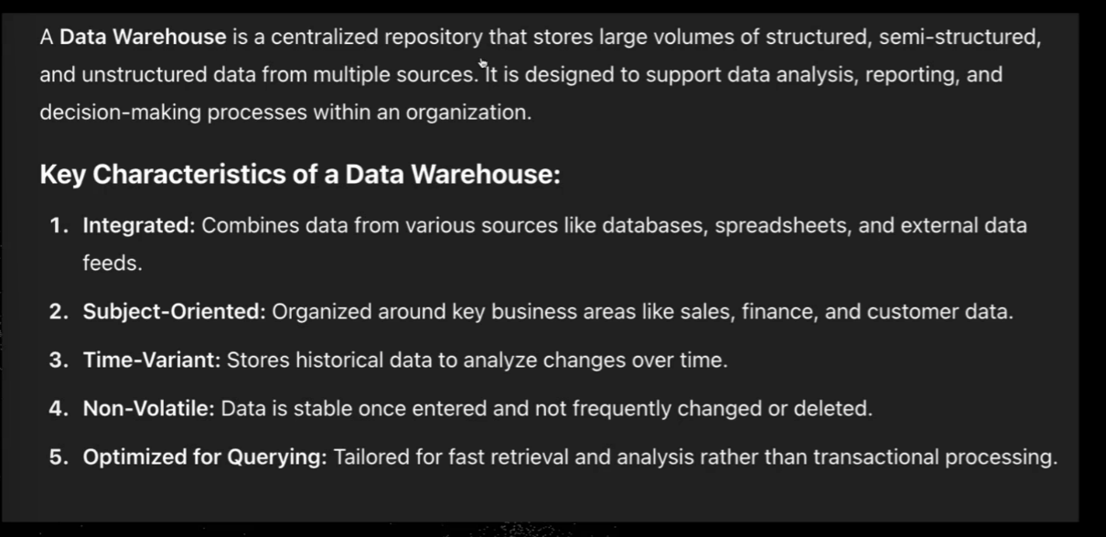

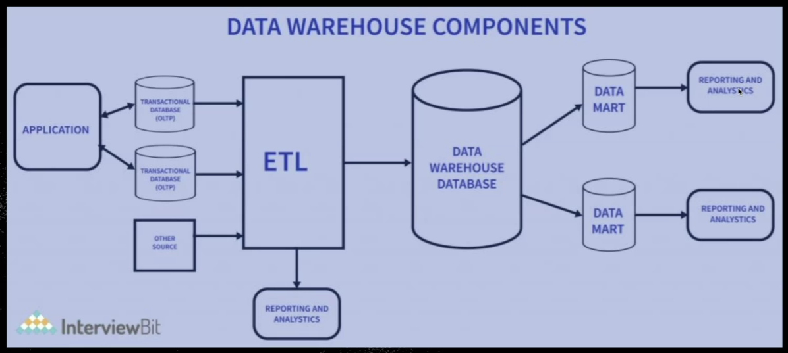

Etl-Extract transform load (cleaning of data)

Data wharehouse – all data is stored

Datamart – data related to specific department / specific oriented data

